Covid 19
Information for Parents of Sunny Days Pre School.

Devised June 2020.
Due to the ongoing adaptations required to ensure all children, families and staff stay safe and healthy throughout the pandemic this document is subject to change. Parents will be notified of any changes without delay however changes may occur with short notice due to circumstances beyond our control.

What is Covid 19:
Novel coronavirus (COVID-19) is a new strain of coronavirus first identified in Wuhan City, China. The 2019 novel coronavirus has been spreading since it was first reported in December 2019.
Symptoms include fever and respiratory symptoms including coughing and shortness of breath. Generally, coronavirus can cause more severe symptoms in people with weakened immune systems, older people, and those with long term conditions like diabetes, cancer and chronic lung disease
Please refer to: https://www.nhs.uk/conditions/coronavirus-covid-19/
For up to date guidance, to check for symptoms, information on track and trace, isolation periods and to access testingtesting

Check if you or your child has coronavirus symptoms: If you have any of the main symptoms of coronavirus (COVID-19), you must stay at home (self-isolate) and get a test.
- a high temperature – this means you feel hot to touch on your chest or back (you do not need to measure your temperature)
- a new, continuous cough – this means coughing a lot for more than an hour, or 3 or more coughing episodes in 24 hours (if you usually have a cough, it may be worse than usual)
- a loss or change to your sense of smell or taste – this means you've noticed you cannot smell or taste anything, or things smell or taste different to normal
- Most people with coronavirus have at least 1 of these symptoms.

What to do if you have symptoms
If you have any of the main symptoms of coronavirus:
- Stay at home (self-isolate) – do not leave your home or have visitors. Anyone you live with, and anyone in your support bubble, must also self-isolate.
- Get a test – get a test to check if you have coronavirus as soon as possible. Anyone you live with, and anyone in your support bubble, should also get a test if they have symptoms.

What is Sunny Days doing to ensure all children and staff are protected at this time.

Sunny Days like any other setting or public place at this time cannot guarantee that there will be no exposure to covid 19 through attendance at pre -school. However we have carried out comprehensive risk assessments and we will be taken all precautions. We have a high degree of confidence in the steps that we have taken and would like to relieve parents of any undue concerns or anxieties at such a challenging time. We have provided copies of our risk assessments in full below so you can see the steps that we are taking if you would like more details of the summary below.
Sunny Days Pre School at all times follow government advice and guidance and decisions regarding practice, policy and procedures have been based upon this. Sunny Days will at times deviate from the guidance if they feel more robust measures need to be taken to safeguard everyone who attends sunny days (ie please refer to exclusions whilst awaiting a test result of a person who may have been in the setting)

As per guidance sunny days will not have ‘bubbles’ for those children who attend. Care will be given to ensuring that children between different age group rooms do not mix. However we do need to consider that senior management are members of the same household so precautions will be taken to minimise these risks as far as reasonably possible. In the event an isolation has to occur this will affect all rooms of the nursery. Unless there is a local lockdown with instructions to close all settings sunny days will re open to all families

Enhanced cleaning and sterilisation of resources and the environment will take place. All toys will be sterilised using Milton Disinfectant fluid; this is approved by the Health & safety executive as successful in removing any traces of covid 19. Carpets will be disinfected on a weekly basis. Soft furnishings will be restricted. Toys will be rotated and reduced within the setting to avoid any risks of cross contamination.

Sunny Days will be implementing a strict sickness policy with immediate effect to ensure all children remain protected. No children with signs of illness will be permitted to attend until they are well again.

Sunny Days will be requesting all parents fully understand the protective measures in place by us and by government. If it is suspected any family is not adhering to proper advice which may put all other families at increased risk we will implement an isolation period whereby a child cannot attend. Although we do not wish to be put in this position we hope parents understand that a robust procedure needs to be adhered to as we enter into the new norm.

All external services have been suspended, visitors and parents are not permitted into the setting and adults will adhere to social distancing. This includes the usual settling in sessions. Any essential works will take place outside of opening hours following strict precautions being taken. In the event a authorised person needs to access the setting, eg social worker, police, speech and language therapist contact will be limited an a isolated area will be used.

All parents must ensure that any child is kept at home for any illness for the foreseeable future. Although we are aware of the main symptoms of covid 19 there are instances of people showing different symptoms.

All parents must advise of any child absences prior to the start of their session without fail. The setting needs to be aware of illnesses to monitor any signs of a possible outbreak. This is a general requirement of sunny days for child protection purposes.

The setting will be fogged each day for a minimum of 1 hour after your child leaves. This will ensure that any possible contamination within the environment is reduced significantly. This complies with Health & safety legislation and only approved cleaning solutions will be used.

Children will re settled into the setting, individual plans and staggered drop off and collection times will be put into place to prevent large numbers of people gathering outside the setting. Staff and parents will be required to observe social distancing. Children will be encouraged to but this will not be enforced. Children develop through loving secure relationships with staff and other children

Hand Washing, catch it, bin it, kill it measures will be taken. Children will be required to wash their hands before entering and leaving the setting to minimise the risks of transmission.

Temperature checks may take place prior to a child’s entry into the setting. Entry will not be permitted to any child with a temperature over 37.7 regardless of possible circumstances

If a child has packed lunch or snacks are provided. These are to be prepared by the parent in individual disposable bags/containers on a daily basis. These should be placed on the table provided outside of the setting and these will be suitably cleaned before they are brought into the setting. Hot cooked lunches are provided by an accredited company where we are satisfied strict covid 19 measures are in place to ensure that risks are removed

Sunny Days: What will we do if there is a suspected case of
covid 19 or a child/staff member showing symptoms?

In the event of a child or staff member showing signs of covid 19 all
other children will continue to be safeguarded.

- The child will be taken to a designated area where no others are present the room will be well ventilated

- The staff member will be provided with full PPE including face mask and shield

- The parent will be contacted to immediately collected there child (in all cases within 30 minutes).

- The parent will be expected to access a covid test for their child and adhere to any advice given whilst awaiting a result. The setting MUST be notified of the outcome of this result without delay so necessary steps can be taken

- After collection the area will be thoroughly disinfected and Sunny Days will liase with the HSE to take all measures necessary. Although not a requirement Sunny Days will request that ALL children are collected
So a deep clean can take place ready for re-opening as usual the following day. An immediate notification will be sent out to all parents so collections can occur. Therefore it is COMPULSORY that any parent who does not have the EYLOG parent app contacts clare without delay to ensure this is set up and active for your use.

- All remaining children will be engaging in their normal activities to ensure children are happy and secure whilst awaiting collection

Sunny Days: What happens following a test Result.

What Procedure will be followed in the event of a
confirmed case of covid 19?
In the event of a child, staff or family member
having a confirmed case of covid 19.

The procedure on page 7 will be followed.
However Sunny Days has amended these following procedures to enhance the safeguarding procedures.

- In the event there is a suspected case within the setting, or advised to the setting ALL children will be contacted for collection so as a precautionary measure deep cleaning can take place and advice can be sought from the south East protection Team, we appreciate this may cause disruption which we seek to minimise however we feel prevention is better than intervention.
If there is any indication that covid 19 may be in the setting due to cross contamination we will ensure all precautions are taken.

- All parents will be advised and aware of a possible case of covid 19, procedure dictates that the setting should continue to operate whilst awaiting any individuals test results. Parents are given free choice whether their children return to the setting during this waiting period or if a parent wishes for their child to remain at home until a result has been provided. Although the staff member/child would have been isolated your child would have had contact with surfaces or the individual who may be unwell so therefore parents are invited to risk assess their own current situation and decide how they would like to minimise risks.

- All government isolation periods will be adhered to at all times, we will endeavour to minimize disruption however we do need to respond quickly and effectively and this may mean the setting has to shut for 2 week isolation periods, and longer if a government local lockdown comes into effect

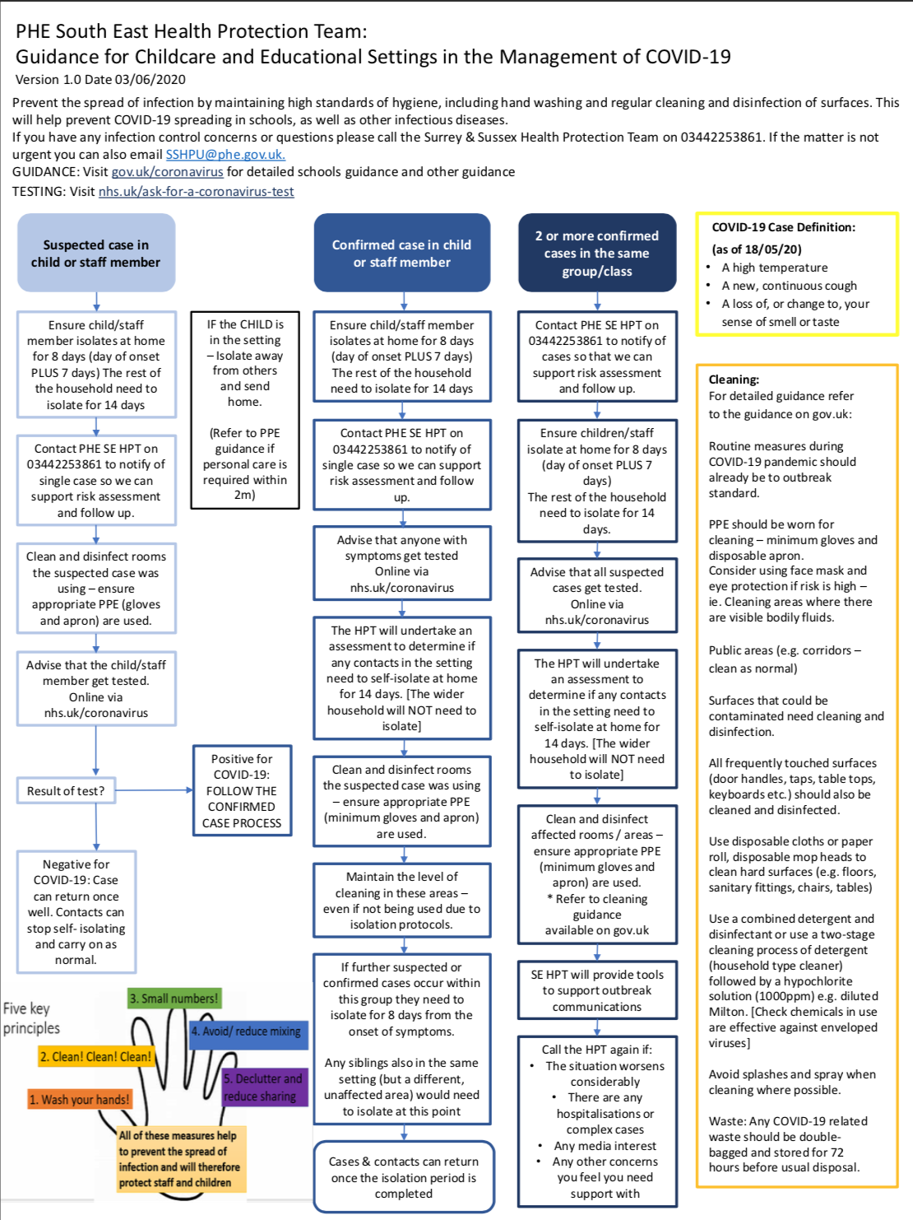

For information purposes only should you require a detailed look at the risk assessments which are being used to inform procedures.
Action Plan Response to covid 19 . June 2020: policy under constant review. Update from Public health England is due August 2020. There may be changes to the resources that can be used in the setting

Focus | Area of consideration | Recommendations
Children | Attendance | - Only children who are symptom free or have completed the required isolation period should attend the setting.  - Any child with symptoms of any illness will be required to remain at home  - temperatures of children on arrival and risk assessing with regular health questionnaires for returning children. Children with any temperature regardless of how small this is will not be permitted to attend the setting and will be required to stay away from the setting for a period of 7 days in compliance with isolation periods.  - Strict attendance, compulsory to only use the setting if no other care is available particularly in 1 key person families to limit risk to staff and others (only in the event a local lockdown occurs which restricts attendance)  - The primary aim is to offer childcare during this time and not focus on learning. However where possible The EYFS will be delivered to ensure that children receive their regular play and learning experience.  - Children are only permitted to attend if there is no other childcare arrangements available, even if only 1 person is a key person. (only in the event a local lockdown occurs which restricts attendance)  - Priority allocations based on criteria; taking into account safeguarding & child’s individual needs and ability to follow independent or supported self care. only in the event a local lockdown occurs which restricts attendance)  - Children will not be able to bring into the setting any toys, objects or bags due to the risks of cross contamination.  - Children’s bags will only be permitted if these are required  - Children to be sent in with own clearly labelled water bottle which is to be stored on their own named pegs  - Children’s pegs will be named and spaced taking into account social distancing  - Any signs of illness, eg runny noses etc children are not permitted to attend under any circumstances
 | Physical distancing/ grouping | - Wherever possible these small groups or ‘bubbles’ should not mix during the day  - Care routines including provision of meals, nappy changing and toiletting should be within the space allocated to each group wherever possible  - The use of communal internal spaces will be restricted as much as possible Outdoor spaces will be used on a free flow basis. In non mobile children staff will ensure that there are ample opportunities for time spent learning outdoors.
 | Wellbeing and education | - children should be supported in age appropriate ways to understand the steps they can take to keep themselves safe including regular hand washing and sneezing into a tissue. Consideration should be given to those who are not able to do this (ie under 3’s)  - Children should be supported to understand the changes and challenges they may be encountering as a result of Covid-19 and staff need to ensure they are aware of children’s attachments and their need for emotional support at this time  - Children should be encouraged not to touch hands, cuddle their friends whilst in the setting, this will be supported but there are significant difficulties with young children maintaining social distancing and the effect on doing so which may affect their emotional wellbeing.  - Children will not be receiving education in line with the EYFS subject to current relaxation. The primary aim is to offer childcare to only those who have no alternative.
Workforce | Attendance | - Staff should only attend the nursery if they are symptom free, have completed the requires isolation period or achieved a negative test result.  - Providers may consider taking temperature of staff on arrival and risk assessing with regular health questionnaires for returning staff  - Limiting staff on duty caring for children to only the required minimum  - Re introduction of staff to be carried out in a phased manner
 | Physical grouping/ distancing | - staff should remain with the small group of children, the ‘bubble’ of children who they are allocated to and not come into contact with other groups.  - Emergency revisions to the EYFS have been implemented which provides some flexibility on ratios and qualifications to make this feasible.  - Social distancing must be maintained at all times  - Staff members are not permitted physical contact with each other including handshakes, hugs etc.  - Where possible, meetings and training sessions should be conducted through virtual conferencing
- All staff members must receive appropriate instruction and training in infection control and the standard operating procedure and risk assessments within which they will be opera4ng
- All staff members to participate in a return to work and suitable health/ mental wellbeing checks
Parents | Physical distancing | - Only parents who are symptom free and or have completed the required isolation periods will be able to drop off or collect their child  - Aim to limit drop off and pick up to 1 parent per family and stagger the 4mings where possible. If at the same time markings should clearly indicate the 2m rule  - drop off and pick up at the nursery entrance to avoid parents entering the nursery unnecessarily  - When parents are waiting to drop off or collect their child, physical distancing should be maintained in a safe area  - Consider allowing parents to enter the nursery for the purpose of settling in sessions if not doing so would cause a child distress. The provider should consider measures to minimise contact between the parent and other children and staff members (in extenuating circumstances only)
 | Communications | - Parents to receive clear communication regarding the role they play in the safe operating procedure and all measures being taken to ensure the safety of their children and themselves  - Parents must respect the importance if informing the setting of any signs of illness of themselves, their child, or any contact with any other person who may be affected. If they have been for the safety of all those who attend parents must adhere to staying at home with their child for 7 days regardless.
Visitors | Visits | - Attendance to the setting should be restricted to children and staff as far as practically possible  - visitors will not be permitted to the nursery unless essential (e.g. essential building maintenance). Where essential visits are required these should be made outside of the usual nursery operational hours where possible. If these are deemed necessary no session will be held with children or staff present.  - Any compulsory visitors such as social workers, SALT advisors will only be permitted with prior consent and must be informed of the policy in regards to attendance with any symptoms.
 | Travel associated with settings operations | - Wherever possible staff and parents should travel to the nursery alone, using their own transport  - If public transport is necessary, current guidance on the use of public transport must be followed  - Parents will not be permitted to leave travel accessories including buggies, car seats, scooters in the setting premises, but rather in external buggy areas if necessary.  - Outings from the setting into the local community will not take place which include mixing with members of the general public
Hygiene & Health and safety | Hand Washing | - All children and staff must wash their hands upon arrival at the nursery  - Children and staff members should be encouraged to wash their hands frequently  - Children should be supervised when using the toilet to ensure this is followed.
 | Cleaning | - An enhanced cleaning schedule will be implemented that includes furniture, surfaces and children’s toys and equipment. Reductions in sessions is paramount to facilitating this  - Communal area, touch points and hand washing facilities must be cleaned and sanitised regularly using Milton
 | Waste disposal | - All waste must be disposed of in a hygienic and safe manner  - Tissues must be immediately disposed of, children are not to store these in pockets. These must be placed in a sealed bin
 | Laundry | - All items within the setting requiring laundering must be washed in line with NHS laundry guidelines  - Disposable cleaning and cloths should be used in the first instance to limit the risk of spreading infection
 | Risk assessments | - All activity will risk assessed and due consideration given to any adaptations to usual practice. It is expected that would include, but not be limited, to the suspension of learning experiences involving materials which are not easily washable such as malleable materials including but not limited to playdough, sand, paint.  - Sessions will not incorporate snack time to reduce groups of children sitting together.
 | PPE (to be reviewed on a rolling basis) | - Government guidance is that PPE is not required for general use in early years settings to protect against COVID- 19 transmission. PPE should continue to be worn as normal for nappy changing and the administration of first aid
Premises | Building | - Where premises have been temporarily closed during the lockdown period or where they may need to temporarily close during future lockdowns appropriate Health & Safety checks should be conducted prior to reopening including legionnaires checks  Keep windows open where possible to ensure ventilation .
 | Insurance | - Contact alternative providers of insurance who will provide suitable cover which meets Ofsted guidelines and protects the indemnity of the setting  - Liase with LEA  - Follow up with LEA on the outcome after referral to the DFE  - Setting not to reopen without insurance coverage; awaiting confirmation
 | Resources | - All resources required for play and learning experiences of children will be regularly washed and/or sterilised  - Resources will not be shared by the ‘bubble’ groups and need to be sterilised before use of another bubble  - Equipment used by staff such as stationary, tablets etc. will not be used.  - Parents will be expected to register their child using their own parent app. Exceptions to staff using these are limited to management to sign children in for accurate attendance records
Supplies | Procurement and monitoring | - The setting will ensure an adequate supply of essential supplies  - We will put in place contingency plans are in place to minimise the impact of any shortages of supplies. The setting will not be able to operate without essential supplies required for ensuring infection control  - staff should complete a checklist monitoring system for the usage of PPE ensure that a supply of stock is available to all who require it as and when required to meet the operational needs of the setting.  - When stocks are low, other op4ons may be considered, such as the use of washable tabards. These items will be washed at a high temperature and separate to any other nursery washing.
Responding to a suspected case | Responding & Reducing risks | - In the event of a child developing suspected coronavirus symptoms whilst attending the setting, they should be collected as soon as possible and isolate at home in line with the NHS guidance. PARENTS should always remain contactable and within distance to be able to collect their child within 30 minutes.  - Whilst waiting for the child to be collected they will be isolated from others in the sensory room. A window will be opened for ventilation  - The staff member responsible for the child during this time should be a staff member from their ‘bubble’. The provider may consider suitable PPE for this staff member.  - The area will thoroughly cleaned, immediately if and if the area can be left unvisited then it should be cleaned after 72 hours  - The person responsible for cleaning the area will wear appropriate PPE  - In the event a child is sent home with symptoms, all other children should be sent home and the nursery left un used for 72 hours before cleaning.  - In the event of a staff member developing suspected coronavirus symptoms whilst working at the nursery, they should return home immediately and isolate at home in line with the NHS guidance.

